DAY 3 LAB EXPERIMENTS

Name:N. Loka bandhava
Reg.no: 192324167
Dept: B.Tech AI & DS

Scenario : You are a data scientist working for a company that sells products online. You have
been tasked with creating a simple plot to show the sales of a product over time.
Question:
1. Write code to create a simple line plot in Python using Matplotlib to predict sales happened in a
month?
2. Write code to create a scatter plot in Python using Matplotlib to predict sales happened in a
month?
3. Develop a Python program to create a bar plot of the monthly sales data.
Solution:
import matplotlib.pyplot as plt
days = [1, 2, 3, 4, 5, 6, 7, 8, 9, 10]
sales = [120, 110, 170, 160, 180, 200, 220, 210, 230, 250]
plt.plot(days, sales,marker='o')
plt.xlabel("Days")
plt.ylabel("Sales")
plt.title("Monthly Sales Trend (Line Plot)")
plt.show()
plt.scatter(days, sales)
plt.xlabel("Days")
plt.ylabel("Sales")
plt.title("Monthly Sales Distribution (Scatter Plot)")
plt.show()
plt.bar(days, sales)
plt.xlabel("Days")
plt.ylabel("Sales")
plt.title("Monthly Sales Data (Bar Plot)")
plt.show()

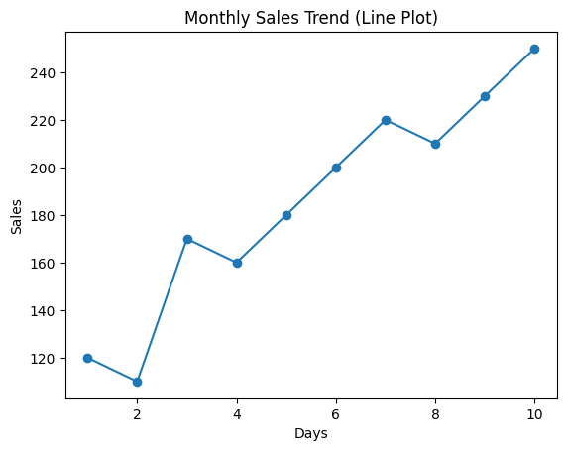

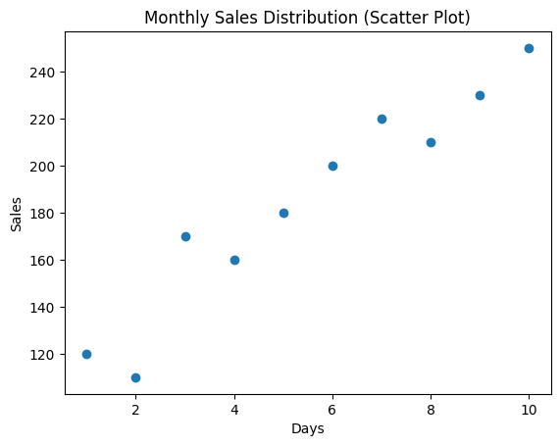
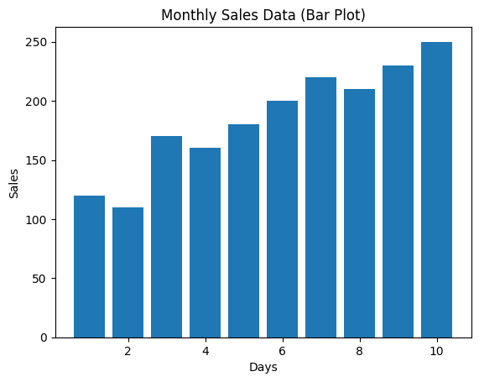

Scenario: You are working on a data analysis project that involves analyzing the monthly
temperature and rainfall data for a city. You have a dataset containing the monthly temperature and
rainfall values for each month of a year. Your task is to develop a Python program that generates
line plots and scatter plots to visualize the temperature and rainfall data.
Question:
1. Develop a Python program to create a line plot of the monthly temperature data.
2: Develop a Python program to create a scatter plot of the monthly rainfall data.
Solution:
import matplotlib.pyplot as plt
months = ["Jan", "Feb", "Mar", "Apr", "May", "Jun",
"Jul", "Aug", "Sep", "Oct", "Nov", "Dec"]
temperature = [18, 20, 25, 30, 35, 38, 36, 34, 32, 28, 23, 19]
rainfall = [30, 40, 35, 50, 60, 120, 150, 140, 90, 60, 45, 35]
plt.plot(months, temperature,color='red')
plt.xlabel("Months")
plt.ylabel("Temperature (°C)")
plt.title("Monthly Temperature Variation")
plt.show()
plt.scatter(months, rainfall,color='green')
plt.xlabel("Months")
plt.ylabel("Rainfall (mm)")
plt.title("Monthly Rainfall Distribution")
plt.show()
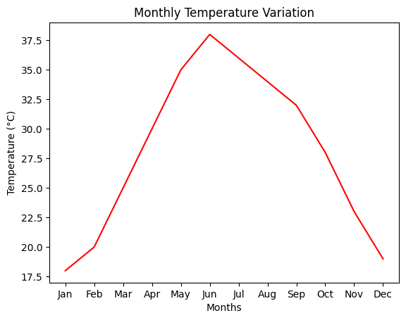
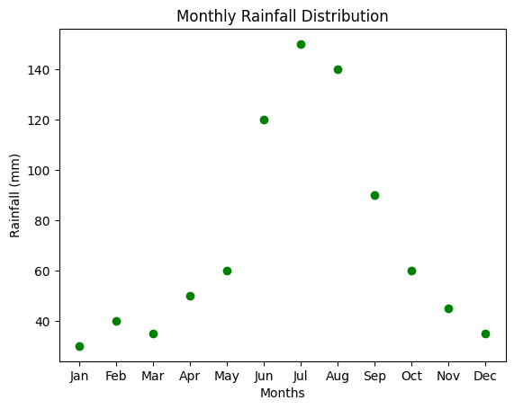
Scenario: You are working on a text analysis project and need to determine the frequency
distribution of words in a given text document. You have a text document named "sample_text.txt"
containing a paragraph of text. Your task is to develop a Python program that reads the text
document, processes the text, and generates a frequency distribution of the words.
Question: How would you develop a Python program to calculate the frequency distribution of
words in a text document?
Solution:
import string
import matplotlib.pyplot as plt
with open("/content/sample(pgm13).txt", "r") as file:
text = file.read()
text = text.lower()
words = text.split()
word_frequency = {}

for word in words:
if word in word_frequency:
word_frequency[word] += 1
else:
word_frequency[word] = 1

for word, count in word_frequency.items():
print(word, ":", count)
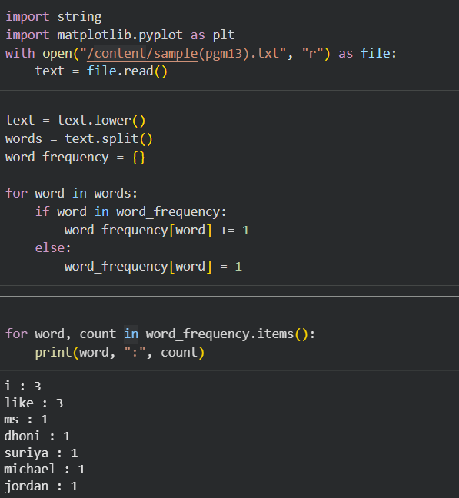

Scenario: You are a data analyst working for a company that sells products online. You have
been tasked with analyzing the sales data for the past month. The data is stored in a Pandas data
frame.
Question: Develop a code in python to find the frequency distribution of the ages of the customers
who have made a purchase in the past month.
Solution:
import pandas as pd
import matplotlib.pyplot as plt
data = {
'Customer_ID': [101, 102, 103, 104, 105, 106, 107, 108],
'Age': [25, 30, 22, 30, 25, 40, 22, 30],
'Purchase_Amount': [500, 1200, 300, 800, 650, 1500, 400, 900]
}
df = pd.DataFrame(data)
age_frequency = df['Age'].value_counts().sort_index()
print("Frequency Distribution of Customer Ages:")
print(age_frequency)
plt.bar(age_frequency.index, age_frequency.values)
plt.xlabel('Age')
plt.ylabel('Frequency')
plt.title('Frequency Distribution of Customer Ages')
plt.show()

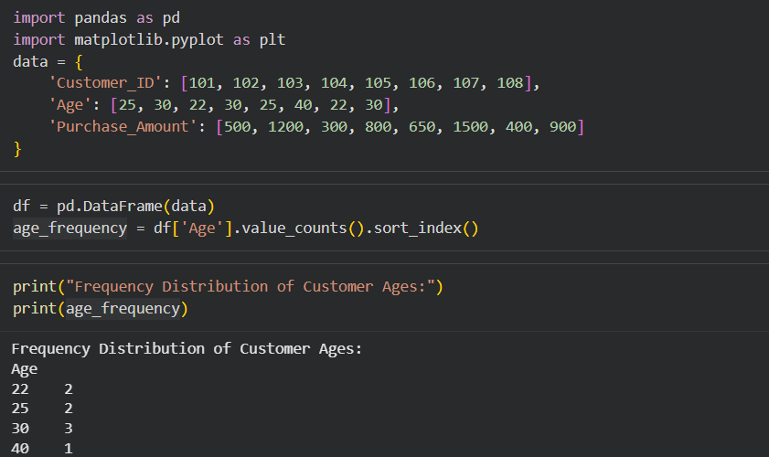

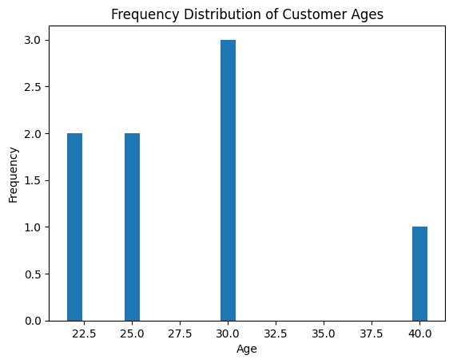

Scenario: You are a data analyst working for a social media platform. As part of your analysis,
you have a dataset containing user interaction data, including the number of likes received by each
post. Your task is to develop a Python program that calculates the frequency distribution of likes
among the posts.
Question: Develop a Python program to calculate the frequency distribution of likes among the
posts?
Solution:
import pandas as pd
import matplotlib.pyplot as plt
data = {
'Post_ID': [1, 2, 3, 4, 5, 6, 7, 8],
'Likes': [120, 45, 120, 300, 45, 200, 120, 45]
}
df = pd.DataFrame(data)
likes_frequency = df['Likes'].value_counts().sort_index()
print("Frequency Distribution of Likes:")
print(likes_frequency)
plt.plot(likes_frequency.index, likes_frequency.values)
plt.xlabel("Number of Likes")
plt.ylabel("Number of Posts")
plt.title("Frequency Distribution of Likes Among Posts")
plt.show()

